To find your current shell type following command-

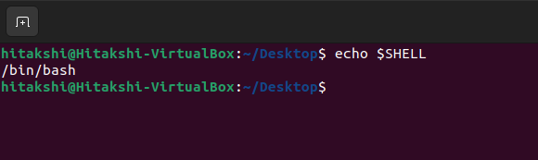

To find all available shells type command-

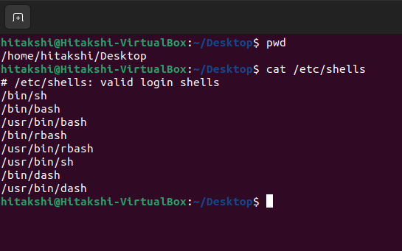

To verify the step(b) use the following command-

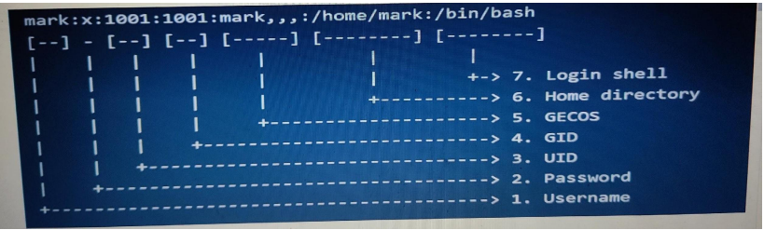

Command typed are : $ who -H myfile1.txt

$ more -d myfile1.txt

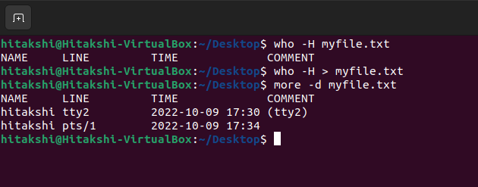

Command typed is : $ sed “s/\([^]\*\)\([^]\)/\2\1/g” test.txt

